Name: Tauseen Ahmed
Lab #1.1: Linear Regression in Python

You’ll need two files to do this exercise: Lab1.1.py (the Python script file) and insurance.csv. Both of those files can be found on the BrightSpace. The data comprises medical costs billed by health insurance and 5 aspects for 1339 individuals.

Download both files and save them to the folder where you keep your Python files.

Part 1: Look at the Data File

- Open the insurance.csv data file. You’ll see something like this:

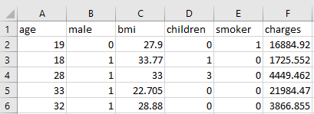
This is the raw data for our analysis. The first line contains the names of the fields. You can see the first field is called age, the second field is called male, the third field is called bmi, and so on. The remaining lines of the file contain the data for each individual.

Here is the full list of the variables:
Variable Name | Variable Description
age | age of primary beneficiary
male | insurance contractor gender,1 for male and 0 for female
bmi | Body mass index, providing an understanding of body, weights that are relatively high or low relative to height, objective index of body weight (kg / m ^ 2) using the ratio of height to weight, ideally 18.5 to 24.9
children | Number of children covered by health insurance or number of dependents
smoker | Smoke or not, 1 for smoker and 0 for non-smoker
charges | Individual medical costs billed by health insurance

We will use this dataset to examine the correlation between the charges and bmi.

charges is a typical outcome variable for regression analysis because it describes a continuous value.

- Close the insurance.csv file. If it asks you to save the file, choose “Don’t Save”.

Part 2: Explore the Lab1.py Script
- Start PyCharm.

- Open the Lab1.1.py file. Click File—Open—Direct to Lab 1.1.py

This contains the Python script that performs linear regression analysis.

- Look at line 2 to 11. These are trying to import packages for our analysis. However, before this step, we will need to install the to-be-imported packages in PyCharm. Please watch the below video.

https://www.youtube.com/watch?v=zCO3KxV2zPI

- Look at lines 12. These define the working directory where you can find your files and save your results.

- Look at lines 16 to 20. These define the input and output files. Here’s a rundown:

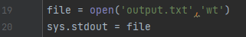

- Now let’s look at the simple linear regression model with only one predictor. Scroll down to lines 30-39:
You can see a few things at work:

- The sm.ols() function is used to fit linear regression models. Here, sm is the name you defined for the package “statsmodels.api”.
- If you suspect heteroskedasticity (unequal variance in residuals), use White’s heteroskedasticity-robust standard errors (HC0)
- The formula for a simple linear regression model is (y,x)
- charges is the outcome event
- bmi is the independent variable.

- Now let’s look at the multiple linear regression model with more than one independent variables. Scroll down to lines 56-65:
The only change compared to the previous one is that now we have more than independent variables (i.e. age, male, children, and smoker). Specifically, now we are looking at the correlation of not just bmi, but also the age, gender, number of kids, and whether smoking, with charges.

- In summary, the most relevant code to estimate the linear regression model is:

Part 3: Execute the Lab 1.1.py Script
- Change current working directory
- Select Run/Run ‘Lab 1.1’. It could take a few seconds to run. Be patient!

- You will see two pictures pop up. They are the ploy you created to compare the predicted value with the actual value of the dependent variable. Take a look and close them. The code will continue to run.

Part 4: Interpreting the Output
We fit a model to our data. That's great! Now we can look at the details of this fit with the summary function:

> # Invoke the summary function on any model you've fit with ols and get some metrics indicating the quality of the fit


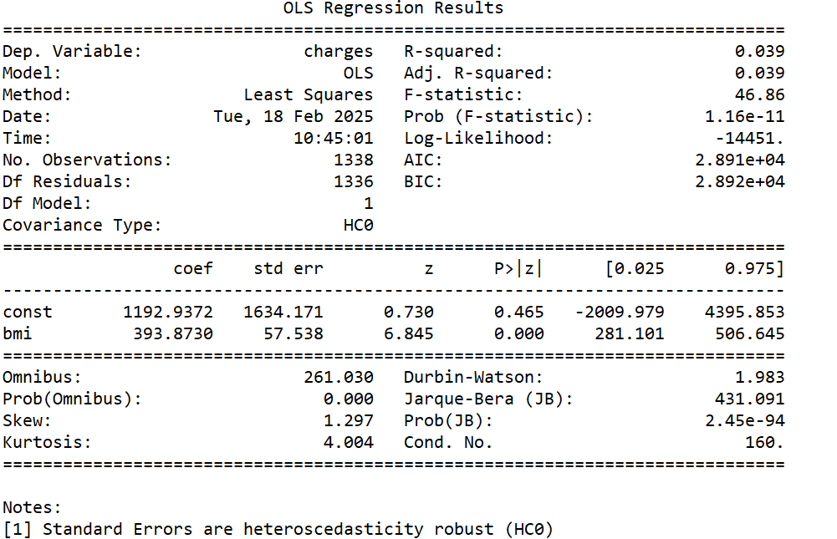

This output contains a lot of information. Let's look at a few parts of it.
- Briefly, it first shows that the function was called; charges (y) explained by bmi (x) using ols, with a constant. The regression equation we would like to fit would be $\hat{charges}=b_{0}+b_{1}bmi$.

- This table, the most interesting part, is the coefficients- this shows the correlation of predictors and the significance of each.

- First, we have our estimate of the intercept ($b_{0}$): the estimated value of $b_{0}$ is 1192.94. Hypothetically, if we have a person with bmi of 0, the predicted charges based on our linear model would be 1192.94.

- Then we can see the effect of the bmi variable on charges ($b_{1}$): the estimated value of $b_{1}$ is 393.87, which shows the effect of bmi. This shows that there's a positive relationship, where increasing the bmi increases the charges. In particular, it shows that increasing the bmi by 1 increases the charges by 393.87.

- So the table gives us the fitted regression line: $\hat{charges}=1192.94+393.87bmi$. You can then use this equation to predict the charges of a person that has a bmi of, say, 23.5.

- This second column is called the standard error: we won't examine it here, but in short, it represents the amount of uncertainty in our estimate of the slope.

- The third column is the t-value of the coefficient estimate, a mathematically relevant value that was used to compute the last column, which is the p-value, describing whether this relationship could be due to chance alone. Smaller p-values (typically with p-value<0.05) indicates that the relationship is statistically significant.

- R-squared: used to evaluating the goodness of fit of your model. Corresponds with the amount of variability in what you're predicting that is explained by the model. In this instance, 4% of the variation in charges can be explained by bmi.

- Adj. R-squared: Similar to multiple R-squared, but will have a small penalty if you include more variables.

Part 5: Try it yourself:
We still use this dataset to examine the correlation between the chagres and bmi. Looking at the results returned by ‘results_model2 = model2.summary()’, and try to interpret the output.

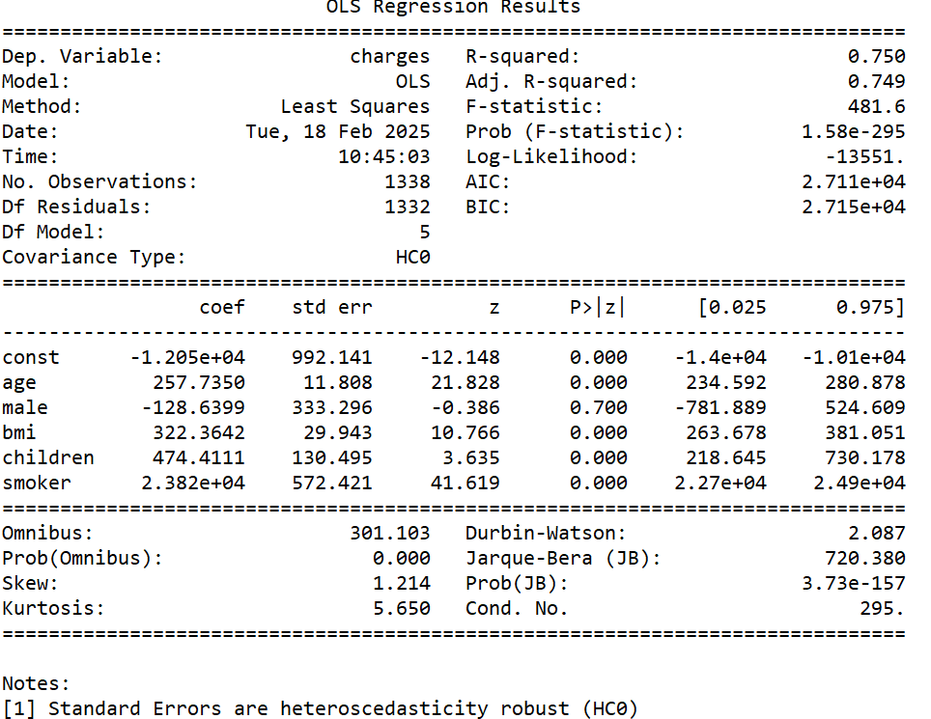
Questions:
1) What is the dependent variable and what are the independent variables in the model?
The dependent variable is charges, and the independent variable is male, children, smoker, bmi

2) What does the Intercept of -1.205e+04 mean?
The intercept of -1.205e+04 mean that the value of charges will be this number is all the independent variables are equal to 0.

3) Which predictor variables are statistically significant in predicting charges?
The predictor variables are statistically significant in predicting charges are age, bmi , children and smoker because they all have a P value < 0.05.

4) What is the coefficient of children? Is this coefficient significant? What does the coefficient mean?
The coefficient of children is 474.41 . This coefficient is significant because the P value of 0.000597 of children is less than 0.05. The coefficient means that when all the independent variables remain unchanged, for every one increase in children the dependent vairable charges increase by 474.41.

5) What are the four key assumptions when using OLS to estimate this model?
The four key assuptions when using OLS to estimate this model are:
1. The Error Term has Condiitonal Mean of Zero
2. Independently and Identically Distributed Data
3. Large Outliers are Unlikely
4. No perfect correlation between regressor which is only applicable to multiple regression.

6) What are the critical diagnostics for linear regression we talked about in the class? Are the estimates reliable based on results of these critical diagnostics?

The critical diagnostics for linear regression we talked about in class are:
Regression diagnostic 1: Multi-collinearity issue which based on the correlation matrix, we didn’t see high correlation between any two independent variables. This model does not have multi-collinearity issue.
Regression diagnostic 2: Based on the results of the White test, this model does have heteroscedasticity issue since the p value of the test is less than 0.05.
Regression diagonstic 3 : model specification errors
1. The model omits important core variables such as drinking habits, which may influence both BMI and charges
2. The model does not include unnecessary or superfluous variables.
3. Although the linear regression is appropriate because the dependent variable is continuous, the charges variable is highly skewed, so using the logarithm of charges would be more suitable.
4. It is unclear whether there are measurement errors since the way variables were measured is not specified
5. Based on the summary statistics, there do not appear to be significant outliers in either the dependent or independent variables

The estimates are not reliable based on results of these critical diagnostics because the probability distribution of the error term is well specified, we check whether the residuals are normally distributed which in this case it is not.

7) Does your model have any omitted variables? List three of them and explain your reason.
The model does have ommitted variables they are chronic illness, education level and income.
Chronic illnesses or pre-existing conditions can lead to higher medical charges.
Education level affects health literacy and healthcare decisions, influencing medical costs.
Income and employment status impact access to healthcare and can alter medical expenses.

8) Can we say “bmi” has a causal “impact” on charges? Why?
We can not say that bmi has a causal “impact” on charges because the result only shows correlation as there could be omitted variable bias.

